Laboratory 3

1. The difference between DDL and DML. Data Definition Language - is a standard for commands that define the different structures in a database. DDL statements create, modify, and remove database objects such as tables, indexes, and users.

A **data-manipulation language** (**DML**) is a language that enables users to access or ma- nipulate data as organized by the appropriate data model.

1. CREATE TABLE table_name (), ALTER TABLE table_name add constraint …, DROP TABLE table_name
2. SELECT * FROM table_name, DELETE FROM table_name, UPDATE table_name SET …, INSERT INTO table_name (…) VALUES (…)
3. -- Second exercise  
     
   CREATE TABLE customers  
   (  
    id integer primary key not null,  
    full_name varchar(50) not null,  
    timestamp timestamp not null,  
    delivery_address text not null  
   );  
     
     
   create table orders (  
    code integer primary key,  
    customer_id integer references customers(id),  
    total_sum double precision not null,  
    is_paid boolean not null  
   );  
     
   create table products (  
    id varchar primary key,  
    name varchar unique not null,  
    description text,  
    price double precision not null  
   );  
     
   create table order_items (  
    order_code integer references orders(code),  
    product_id varchar references products(id),  
    primary key(order_code, product_id),  
    quantity integer not null  
   );  
     
   alter table order_items  
   add constraint quantity check (quantity >0);  
     
   alter table orders  
   add constraint total_sum check (total_sum > 0);  
     
   alter table products  
   add constraint price check (price > 0);
4. 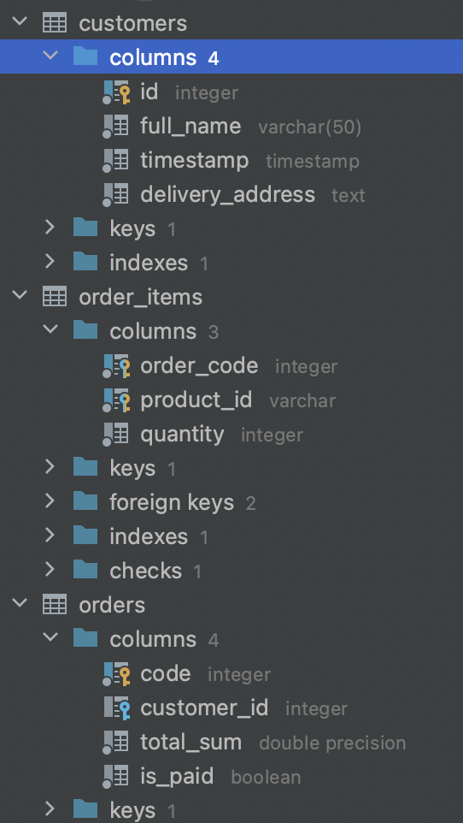

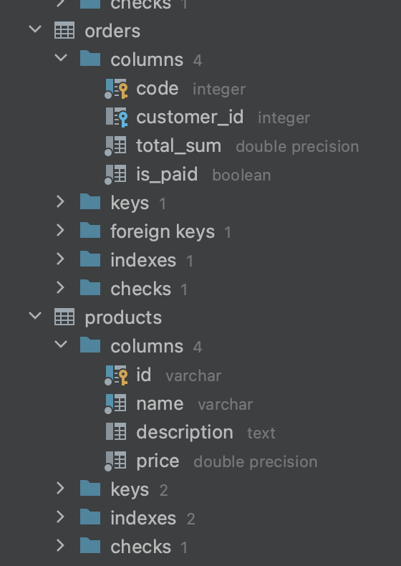

1. -- Third exercise  
     
   create database university;  
     
   create type gender as enum('Female', 'Male', 'Other');  
     
     
   create table students (  
    full_name varchar(50) primary key,  
    age integer not null,  
    birth_date date not null,  
    gender gender not null,  
    average_grade float(3) not null,  
    information_about_yourself text,  
    need_for_dormitory boolean not null default false,  
    additional_info text  
   );  
     
     
   alter table students  
   add constraint age check (age > 0),  
   add constraint average_grade check (average_grade>=0 and average_grade<=4.0);  
     
     
     
   create table instructors (  
    full_name varchar(50) primary key,  
    speaking_languages varchar[] not null,  
    possibility_of_remote_lessons boolean not null  
   );  
     
     
     
   create table work_experience (  
    full_name varchar references instructors(full_name),  
    company_name varchar,  
    job_title varchar,  
    duration_years integer,  
    additional_info text  
   );  
     
     
     
     
   create table lesson_participants (  
    lesson_title varchar not null,  
    teaching_instructor varchar(50) references instructors(full_name),  
    studying_students varchar unique references students(full_name),  
    room_number integer not null  
   );  
     
     
   insert into lesson_participants (lesson_title, teaching_instructor, studying_students, room_number)  
   values ('DBMS', 'Instructor1', 'Student2', 54);  
     
   select * from lesson_participants;  
     
   select * from students;  
     
   insert into students (full_name, age, birth_date, gender, average_grade, information_about_yourself, additional_info)  
   VALUES ('Student2', 19, '01.11.2003', 'Female', 3.444, '','');
2. -- Fourth exercise  
   insert into customers (id, full_name, timestamp, delivery_address)  
   VALUES (1, 'CustomerName', '12.01.2022 23:03:04', 'Address1');  
     
   insert into customers (id, full_name, timestamp, delivery_address)  
   VALUES (2, 'CustomerName2', '12.01.2022 23:03:04', 'Address2');  
     
   insert into orders (code, customer_id, total_sum, is_paid)  
   VALUES (1, 1, 3000, false);  
     
   delete from customers where id =1;  
     
   update customers  
   set full_name = 'SecondChangedCustomerName'  
   where id = 2;  
     
     
   select * from customers;  
     
   select * from orders;